**ELECTRICITY BILL MANAGEMENT**

1. **Version Control**

|  |  |  |
| --- | --- | --- |
| **Modifier** | **Date** | **Description** |
| Tamilselvan A | 03-AUG-2022 | Added Basic Information for Aim of the Project |

1. **Requirement**

**IDE -** STS **/** Eclipse / Vs Code  
**Database** -MySql / Oracle **Language -** Java, Java Script **Framework -** Spring, Angular (or React)

1. **Problem Statements**

Consider a user want to find the average or nearly electric bill for his/her home appliances  
prior to actual bill cycle based on Government EB rates (change as demand).  
  
Note: Information of rates - <https://mykalvi.com/tneb-bill-calculator/>  
  
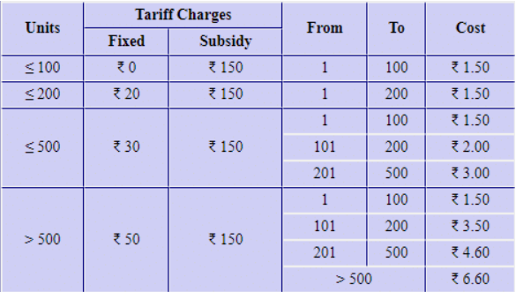

1. **Solution**

|  |  |  |
| --- | --- | --- |
| **Development** | **Components** | **Description** |
| Client / Front End | Login Page | Assume Official Page EB  Assume Based Service Number to login |
| Home Page | Add one field – provide total consumption in units ( kwh)  Will calculate the charge need to pay |
| Second Page | A form have list of Electrical appliance  with two fields each  1. Total power need (watts) 2. Total hours of that appliance in use (hrs)  Formula to Calculate One Unit ; = P x t (kwh) |
| Detail Page | Assume – we provide the detail of usage |
| Server / Back End | DAO | DB connection and handle communication between spring and MySql |
| Configuration | Like Electric rates need config here |
| REST | Act as Middleware between Client and Server |

**Note: Enhance as we need in future.**

1. **Gain of Knowledge**

|  |  |
| --- | --- |
| **Java** | 1. Fundamentals of Java 2. Spring JPA 3. Spring Boot |
| **JavaScript** | 1. Fundamentals of Javascript 2. React |